Let's Meet

Group ID: 05

3005 – Jaishil Bhavsar

3036 – Zeel Modi

3186 – Bhargavi Jansari

**Index**

**Chapter 4: System Analysis and Design1**

4.1 UML (Unified Modeling Language)3

4.2 System Flow Diagram3

4.3 Data Dictionary4

4.4 User Interface4

4.5 System Navigation4

# [**4.1**] UML (Unified Modeling Language)

# [**4.4.1**] Use Case

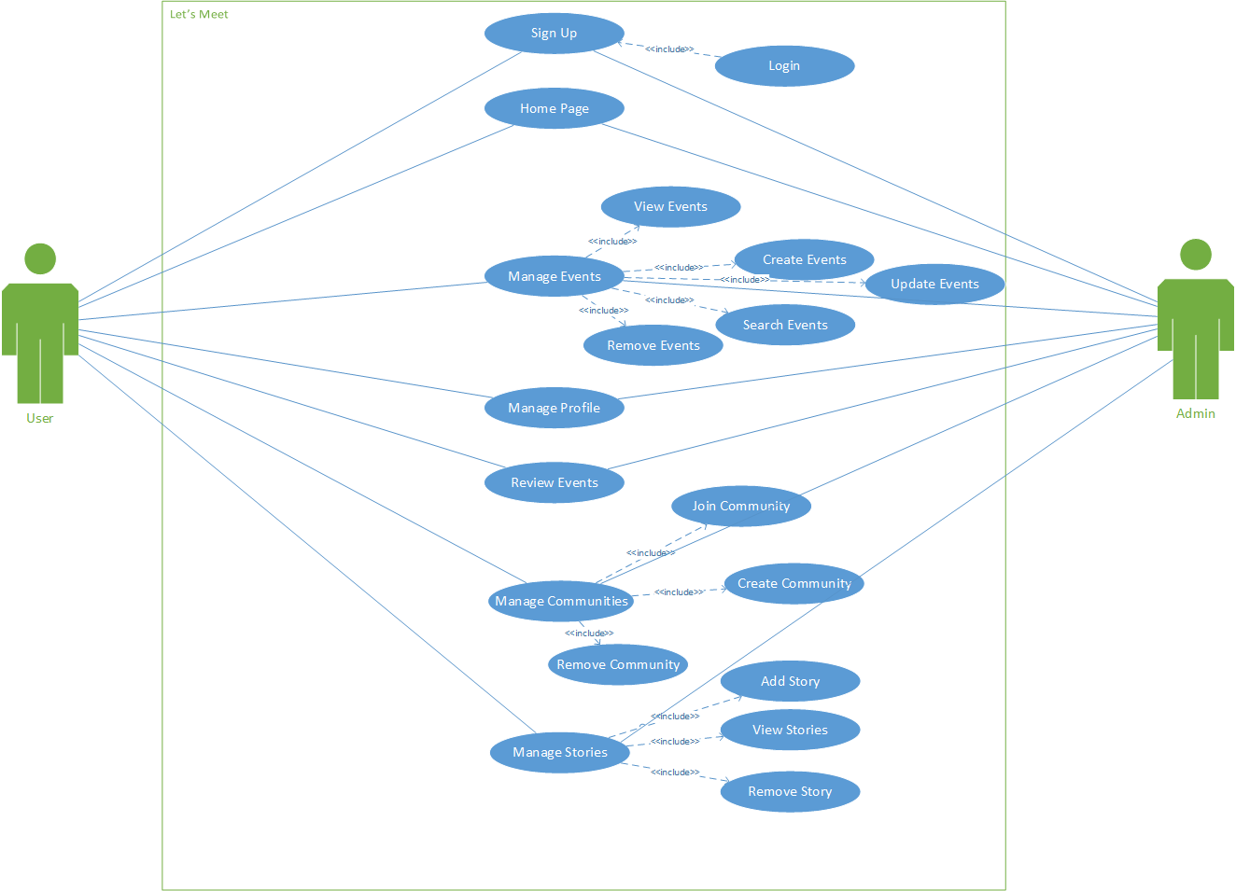

( fig 4.1 – Use Case of System)

# [4.4.2] Class Diagram

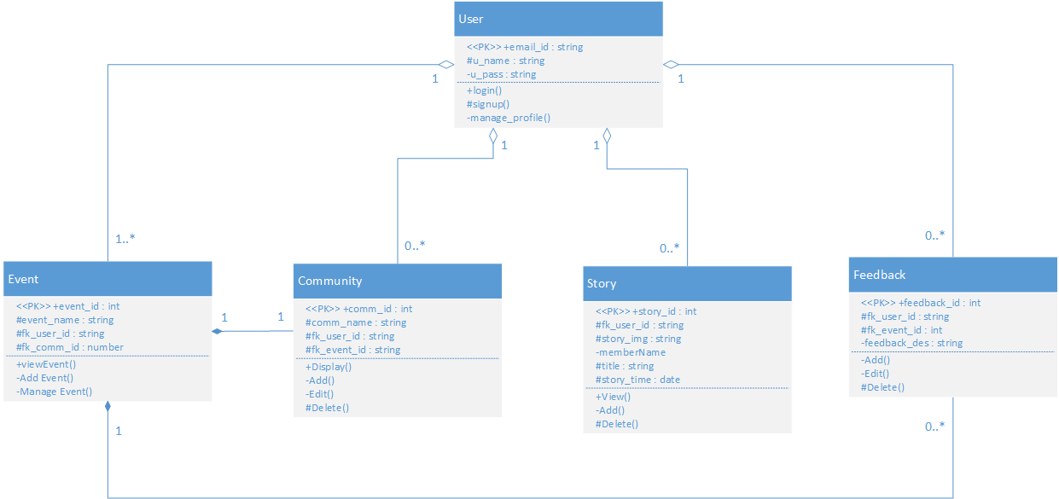

(fig 4.2 – Class Diagram)

# [4.4.3] Activity Diagram

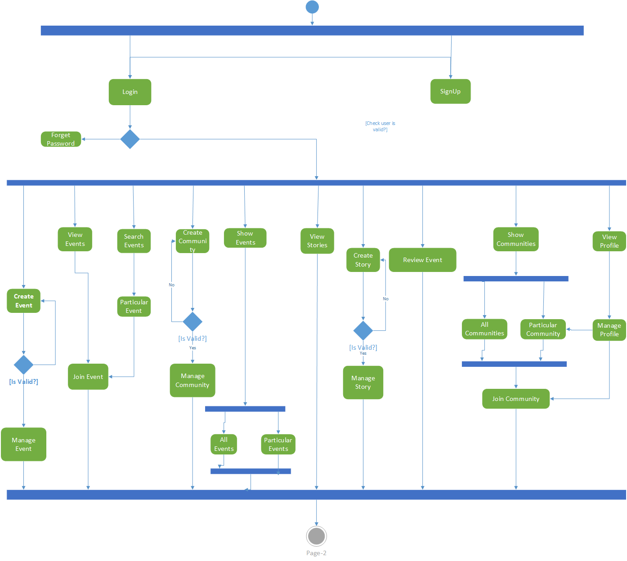

(fig 4.3 – Activity Diagram for User)

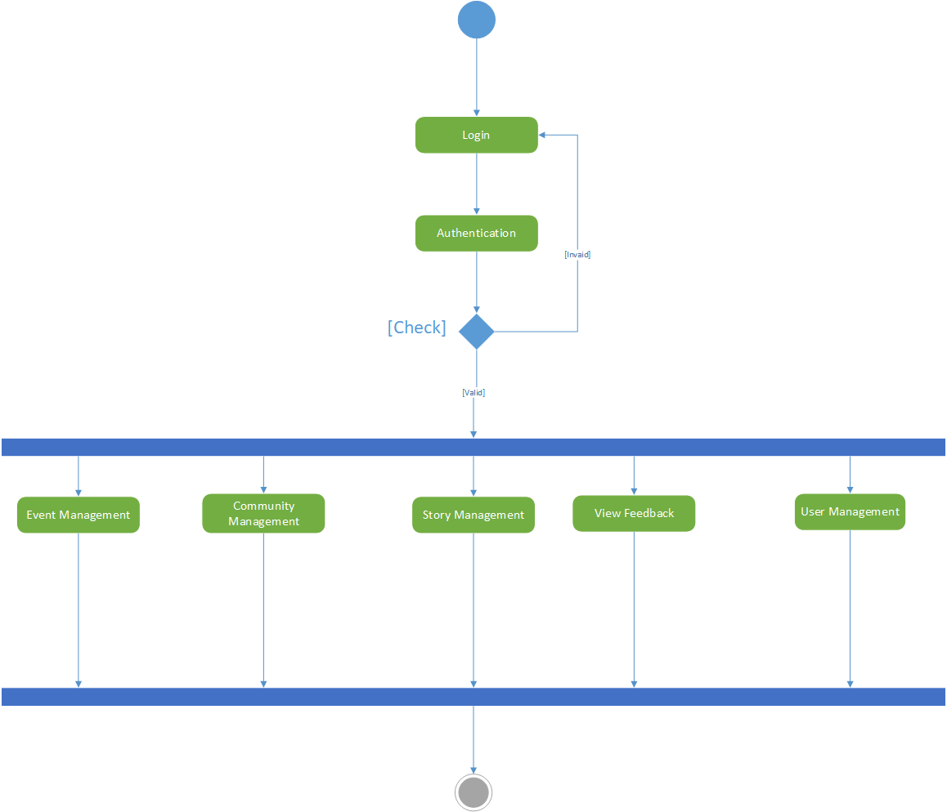

(fig 4.4 – Activity Diagram for Admin)

# [4.4.4] Sequence Diagram

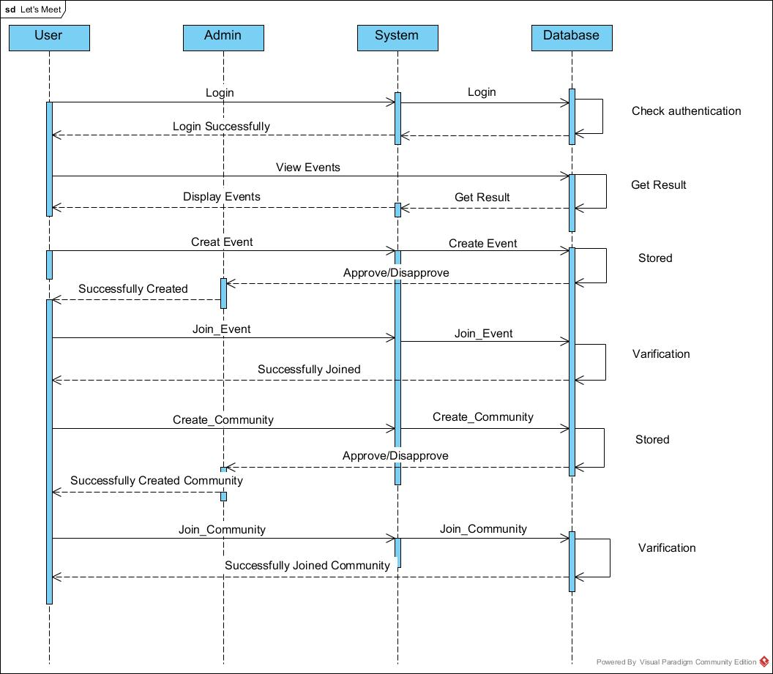

(fig 4.5 – Sequence Diagram)

# 

(fig 4.6 – Sequence Diagram)

# [**4.4.5**] Deployment Diagram

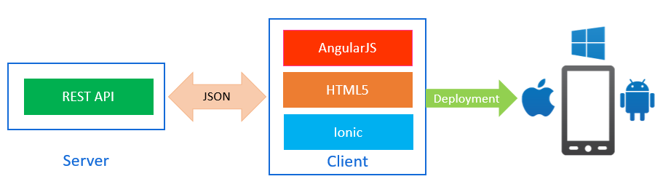

(fig 4.7 – Deployment Diagram)

# [4.2] System Flow Diagram

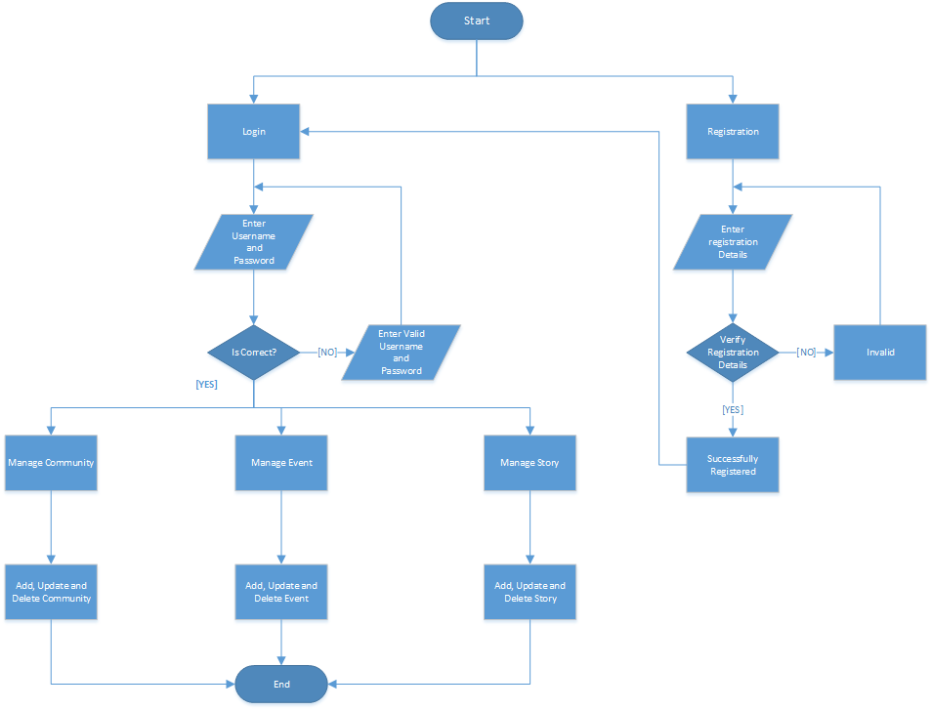

(fig 4.8 – System Flow Diagram)

# [4.3] Data Dictionary

Users

|  |  |  |  |  |
| --- | --- | --- | --- | --- |
| Field | Data-Type | Constrains | Remarks | Description |
| User_id | Varchar(30) | Primary Key | - | User’s email id. |
| User_name | Varchar(20) | Not Null | - | Display User’s Name |
| User_photo | Varchar(500) | - | - | Display Picture |
| Gender | Boolean | - | - | User’s Gender |
| Password | Varchar(10) | Not Null | - | Password for Login |
| Mobile_no | Varchar(15) | - |  | User’s Mobile No |
| Birth_date | Date | - | - | User’s Birth Date |

Communities

|  |  |  |  |  |
| --- | --- | --- | --- | --- |
| Field | Data-Type | Constrains | Remarks | Description |
| Comm_id | Integer | Primary Key | Auto-Increment | Community id |
| Comm_name | Varchar(20) | Not Null | - | Community Name |
| Comm_des | Varchar(300) | Not Null | - | Describe the community |
| Comm_photo | Varchar(500) | - | - | Community Picture |
| Date | Date | Not Null | - | Date created |
| Created_by | Varchar(50) | Foreign Key | - | Users created Community |
| Comm_rating | Integer |  | - | Rating of Community |

Events

|  |  |  |  |  |
| --- | --- | --- | --- | --- |
| Field | Data-Type | Constrains | Remarks | Description |
| Event_id | Integer | Primary Key | Auto-Increment | Event’s Id |
| Event_name | Varchar(100) | Not Null | - | Event’s Name |
| Event_pic | Varchar(500) | - | - | Event Photo |
| Event_des | Varchar(500) | - | - | Event Description |
| Event_time | Varchar(20) | - | - | Event Time |
| Event_date | Date | Not Null | - | Event Date |
| Event_loc | Varchar(100) |  | - | Event Venue |
| Fk_user_id | Varchar(30) | Foreign Key | - | Who Created? |
| Fk_comm_id | Integer | Foreign Key | - | Under Which Community? |

Story

|  |  |  |  |  |
| --- | --- | --- | --- | --- |
| Field | Data-Type | Constrains | Remarks | Description |
| Story_id | Integer | Primary Key | Auto-Increment | Story id |
| Story_pic | Varchar(500) | Not Null | - | Story Photo |
| Fk_user_id | Varchar(30) | Foreign Key | - | Who Posted? |
| Story_title | Varchar(100) | Not Null | - | Story Caption |
| Story_time | Date | Not Null | - | When Story Posted? |

Community Members

|  |  |  |  |  |
| --- | --- | --- | --- | --- |
| Field | Data-Type | Constrains | Remarks | Description |
| Join_id | Integer | Primary Key | Auto-Increment | Community join Id |
| Fk_user_id | Varchar(30) | Foreign Key | - | User who joined community |
| Fk_comm_id | Integer | Foreign Key | - | Which community did user joined |

Feedbacks

|  |  |  |  |  |
| --- | --- | --- | --- | --- |
| Field | Data-Type | Constrains | Remarks | Description |
| Feed_id | Integer | Primary Key | Auto-Increment | Feedback id |
| Fk_event_id | Integer | Foreign Key | - | Under which Event |
| Fk_user_id | Varchar(30) | Foreign Key | - | Who gave feedback? |
| Feed_desc | Varchar(200) | Not Null | - | Feedback Description. |

Posts

|  |  |  |  |  |
| --- | --- | --- | --- | --- |
| Field | Data-Type | Constrains | Remarks | Description |
| Post_id | Integer | Primary Key | Auto-Increment | Post Id |
| Post_title | Varchar(30) | Not Null | - | Caption |
| Post_des | Varchar(200) | - | - | Describe the Post |
| Post_pic | Varchar(500) | - | - | Photo in Post |
| Fk_user_id | Varchar(30) | Foreign Key | - | User who posted this Post |
| Fk_comm_id | Integer | Foreign Key | - | Under which Community |
| Date | Date | Not Null | - | Date Created Post. |

Likes

|  |  |  |  |  |
| --- | --- | --- | --- | --- |
| Field | Data-Type | Constrains | Remarks | Description |
| Like_id | Integer | Primary Key | Auto-Increment | Like id |
| Fk_post_id | Integer | Foreign Key | - | Under which Post |
| Fk_user_id | Varchar(30) | Foreign Key | - | Who liked? |

|  |  |  |  |  |
| --- | --- | --- | --- | --- |
| Field | Data-Type | Constrains | Remarks | Description |
| Com_Id | Integer | Primary Key | Auto-Increment | Comment id |
| Fk_post_id | Integer | Foreign Key | - | Under which post |
| Fk_user_id | Varchar(30) | Foreign Key | - | Who commented? |
| Date | Date | Not Null | - | Date Created |
| Com_des | Varchar(300) | Not Null | - | Content of Comment |

Comments

RSVP

|  |  |  |  |  |
| --- | --- | --- | --- | --- |
| Field | Data-Type | Constrains | Remarks | Description |
| Rsvp_id | Integer | Primary Key | Auto-Increment | RSVP id |
| Fk_user_id | Varchar(30) | Foreign Key | - | Users attending event |
| Fk_event_id | Varchar(50) | Foreign Key | - | Which event user is going to attend? |

Polls

|  |  |  |  |  |
| --- | --- | --- | --- | --- |
| Field | Data-Type | Constrains | Remarks | Description |
| Poll_id | Integer | Primary Key | Auto-Increment | Poll Id |
| Poll_title | Varchar(100) | Not Null | - | Tag line of Poll |
| Option1 | Varchar(50) | Not Null | - | First opinion of poll |
| Option2 | Varchar(50) | Not Null | - | Second opinion of Poll |
| Option3 | Varchar(50) | - | - | Third opinion of Poll |
| Option4 | Varchar(50) | - | - | Fourth opinion of Poll |
| Fk_user_id | Varchar(30) | Not Null | - | Who Created? |
| Fk_comm_id | Integer | Not Null | - | Under Which Community? |

Follower

|  |  |  |  |  |
| --- | --- | --- | --- | --- |
| Field | Data-Type | Constrains | Remarks | Description |
| Follo_id | Integer | Primary Key | Auto-Increment | Follower Id |
| Fk_user_id | Varchar(30) | Foreign Key | - | User being followed |
| Fk_us_id | Varchar(30) | Foreign Key | - | Who Followed? |

Categories

|  |  |  |  |  |
| --- | --- | --- | --- | --- |
| Field | Data-Type | Constrains | Remarks | Description |
| Cat_id | Integer | Primary Key | Auto-Increment | Category Id |
| Cat_name | Varchar(20) | Not Nulll | - | Category Name |

# [4.4] User Interface

Tutorial

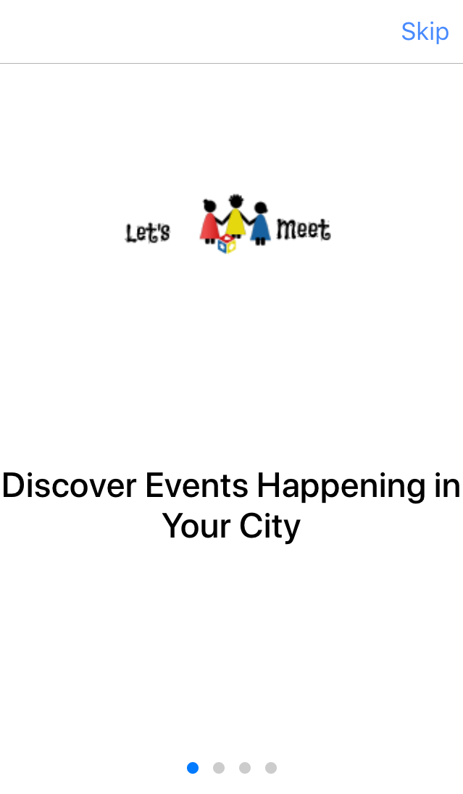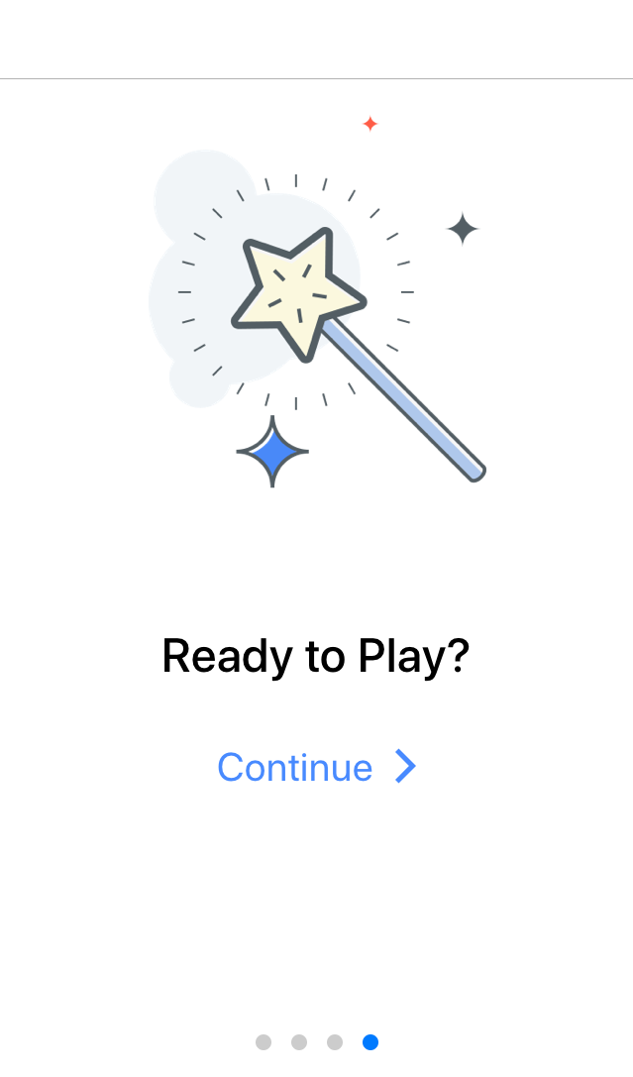

Start-up



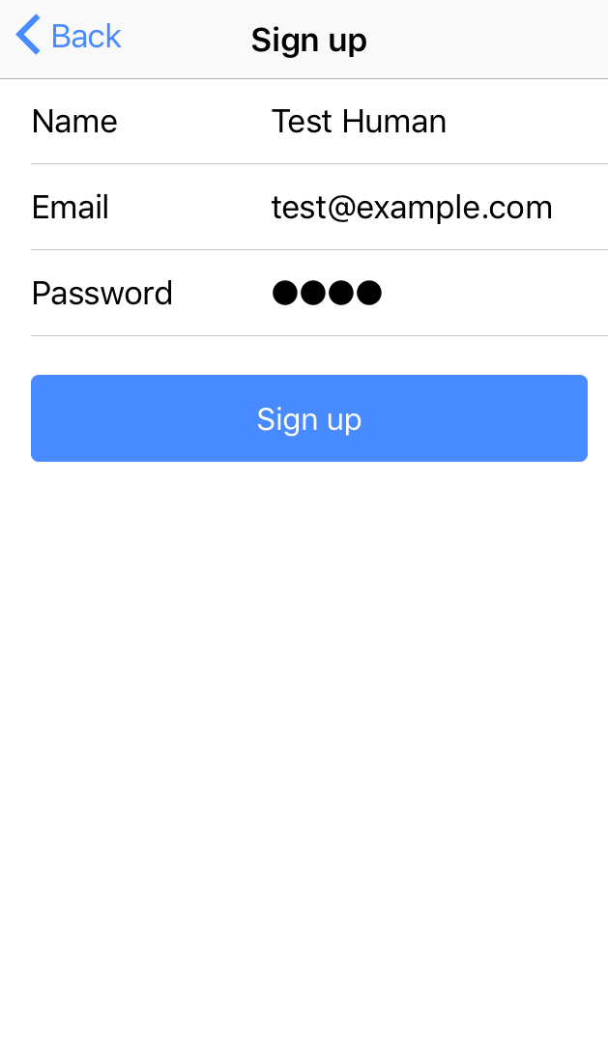Sign Up Page

Sign In Page

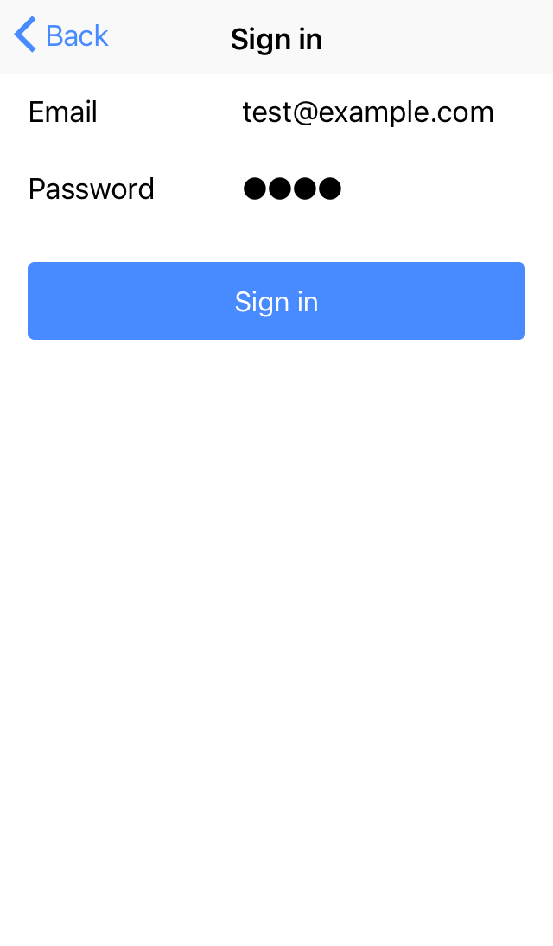

View Events Tab

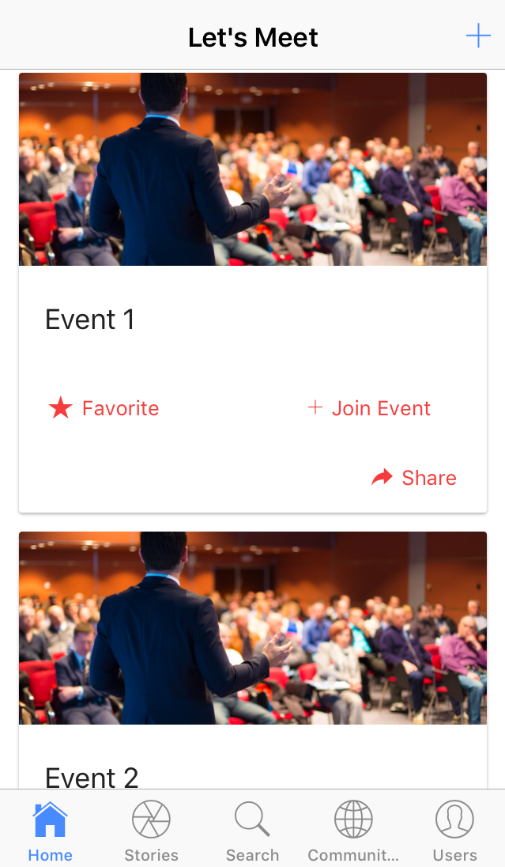

Create Event Page

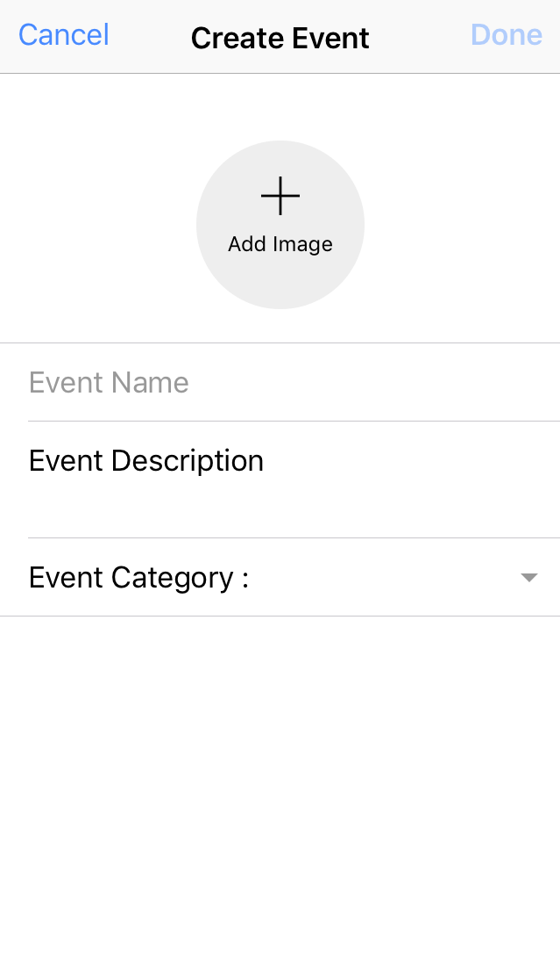

View Stories Tab

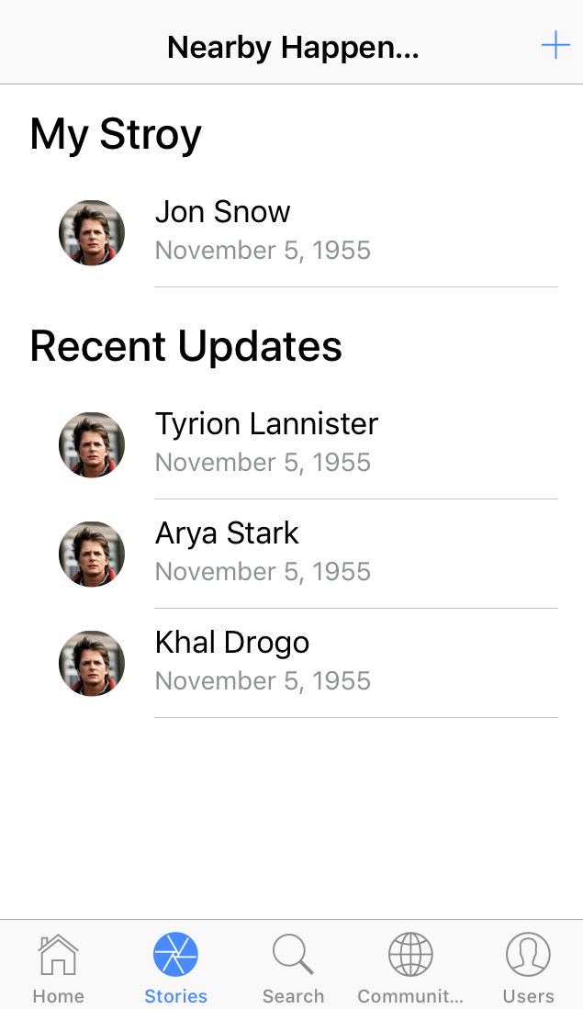

Add Story Page

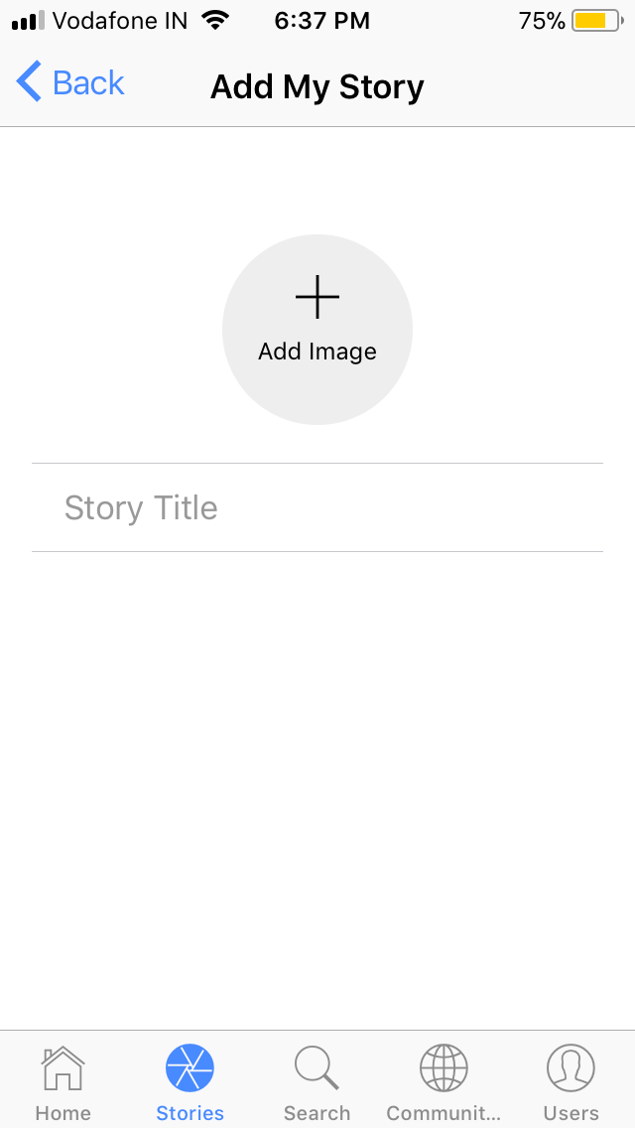

Search Tab

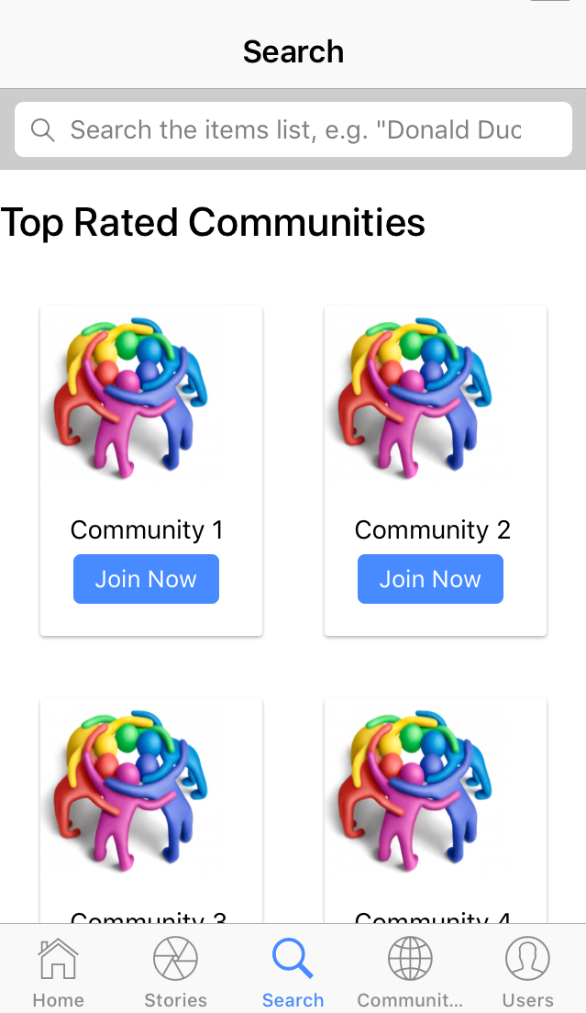

Communities Tab

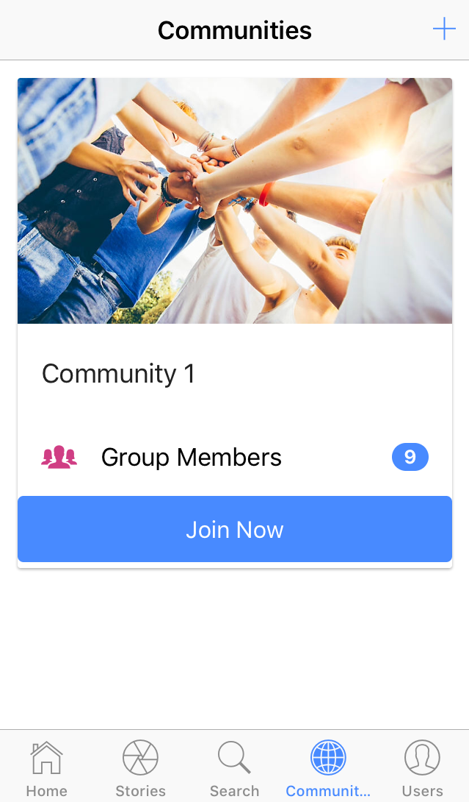

Create Community Page

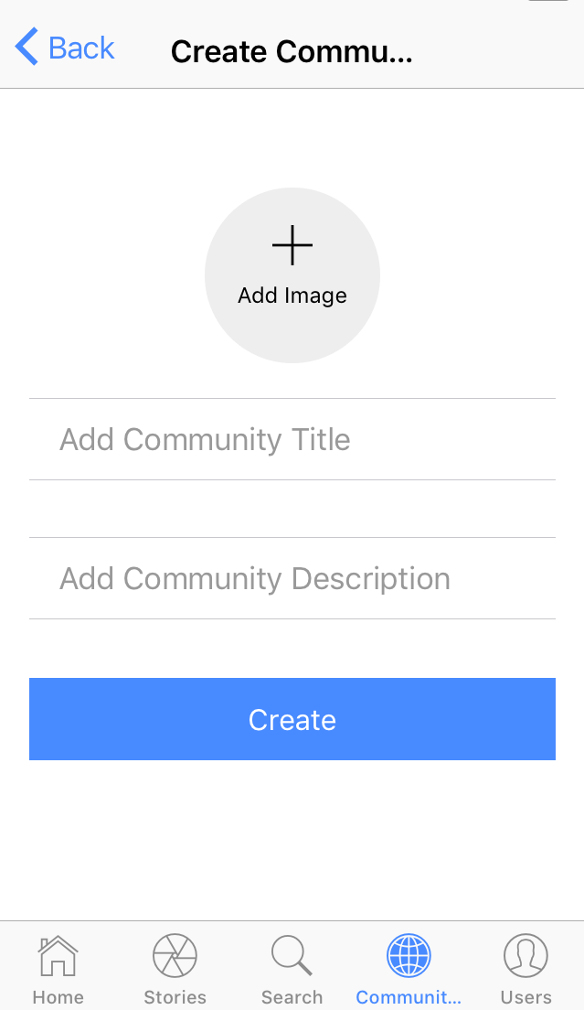

User Profile Tab (Events)

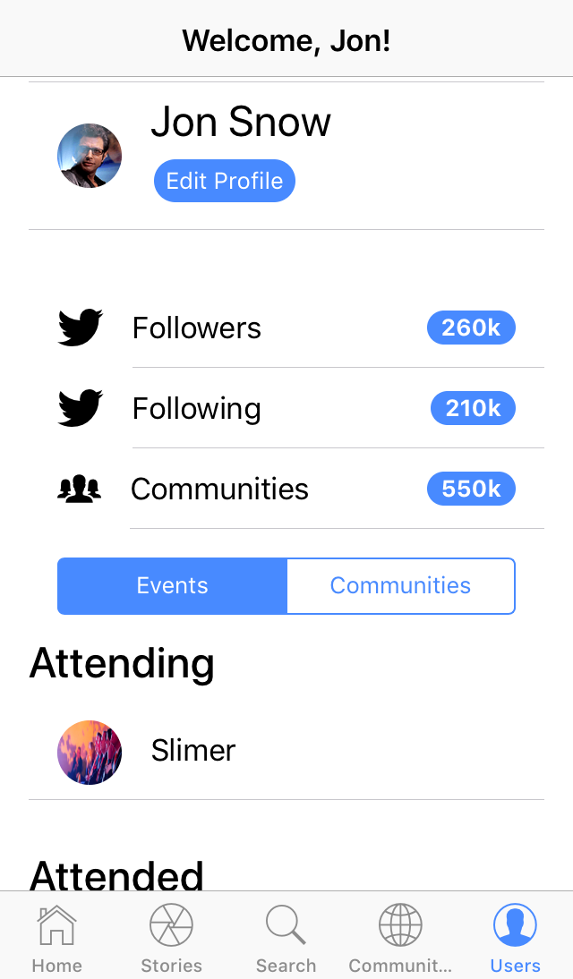 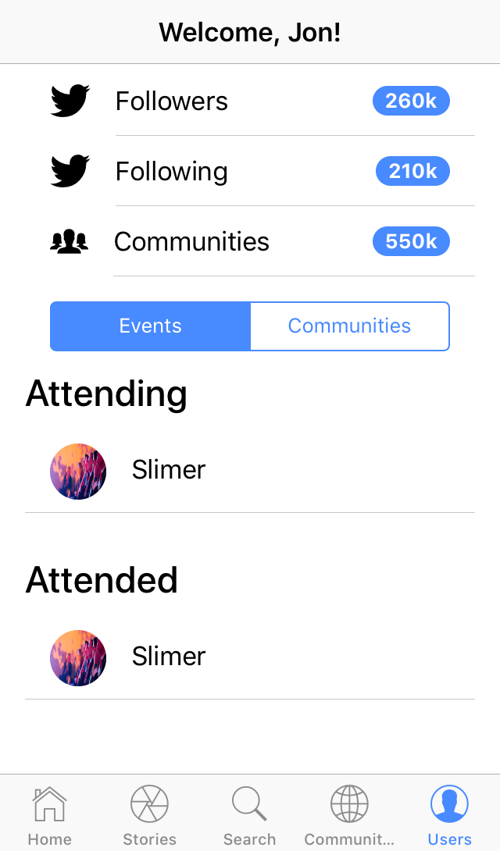

User Profile Tab (Communities)

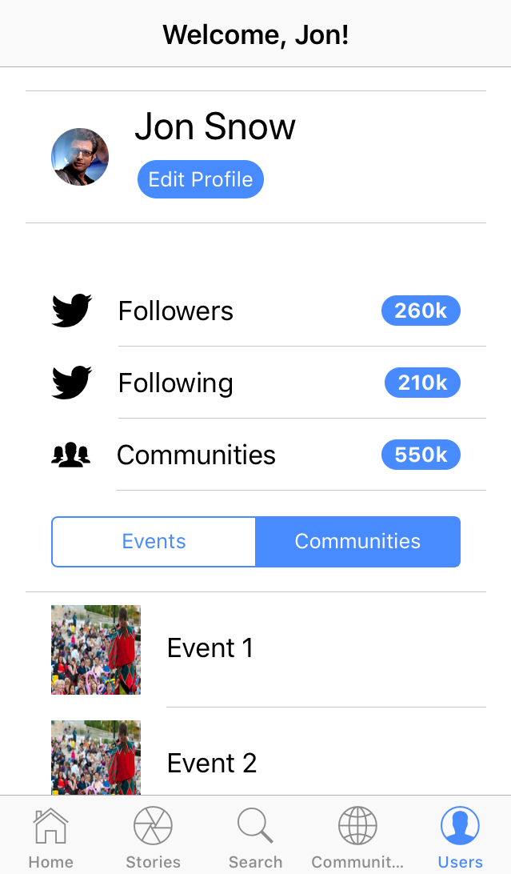

# [**4.5**] System Navigation